# CS 255 System Design Document Template

## UML Diagrams

### UML Use Case Diagram

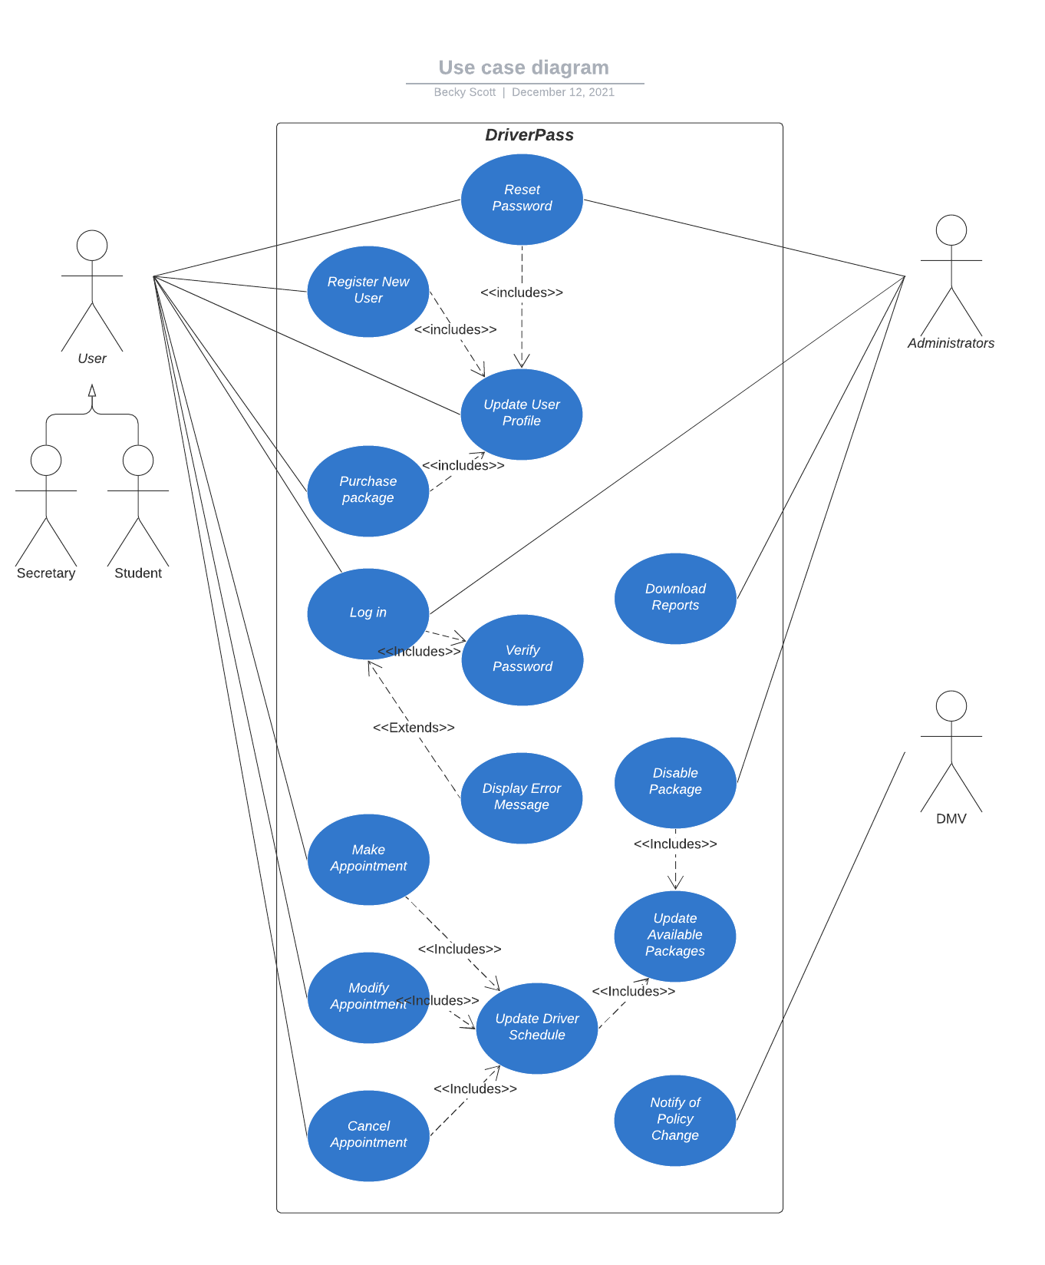

### UML Activity Diagrams

*Buy Package*

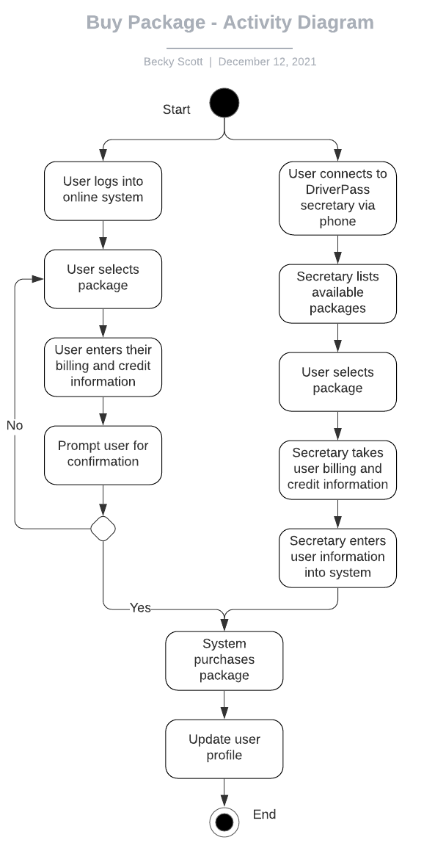

*Book Driver Appointment*

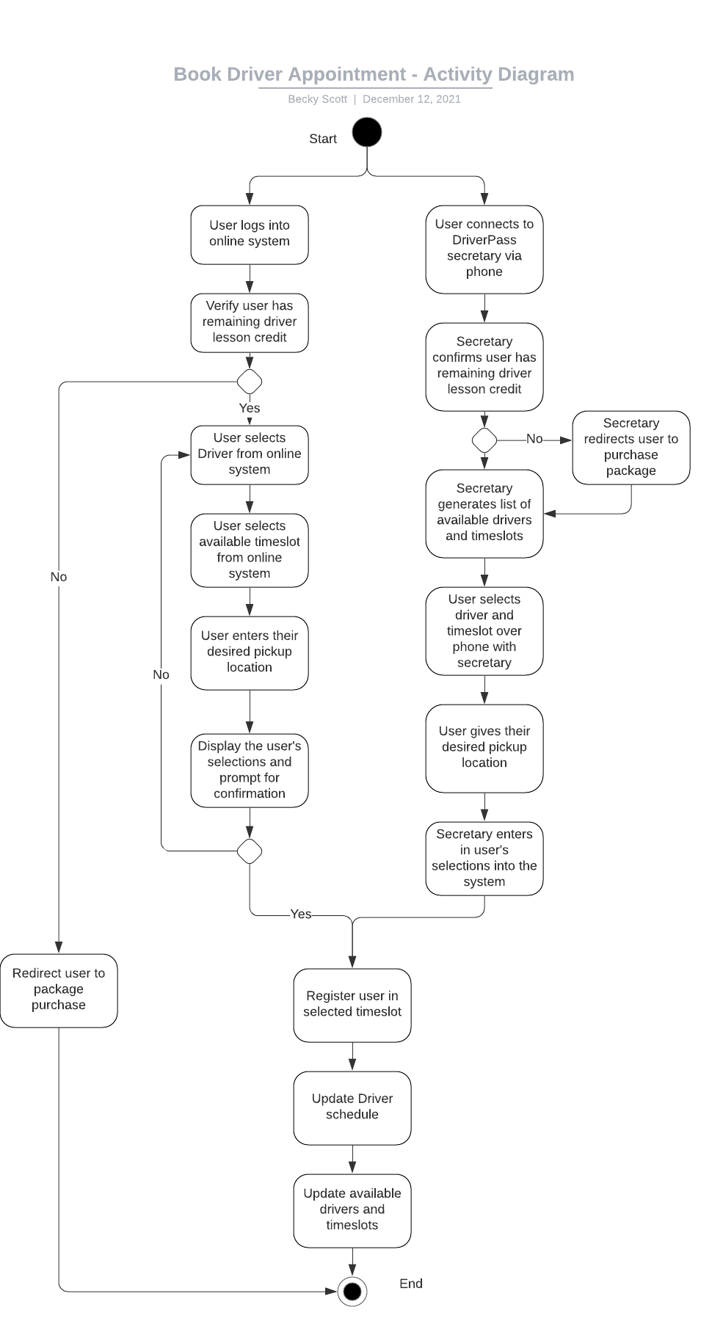

### UML Sequence Diagram

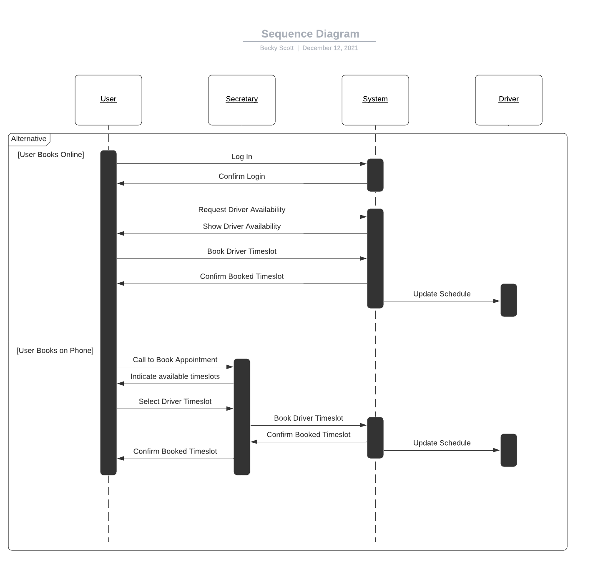

### UML Class Diagram

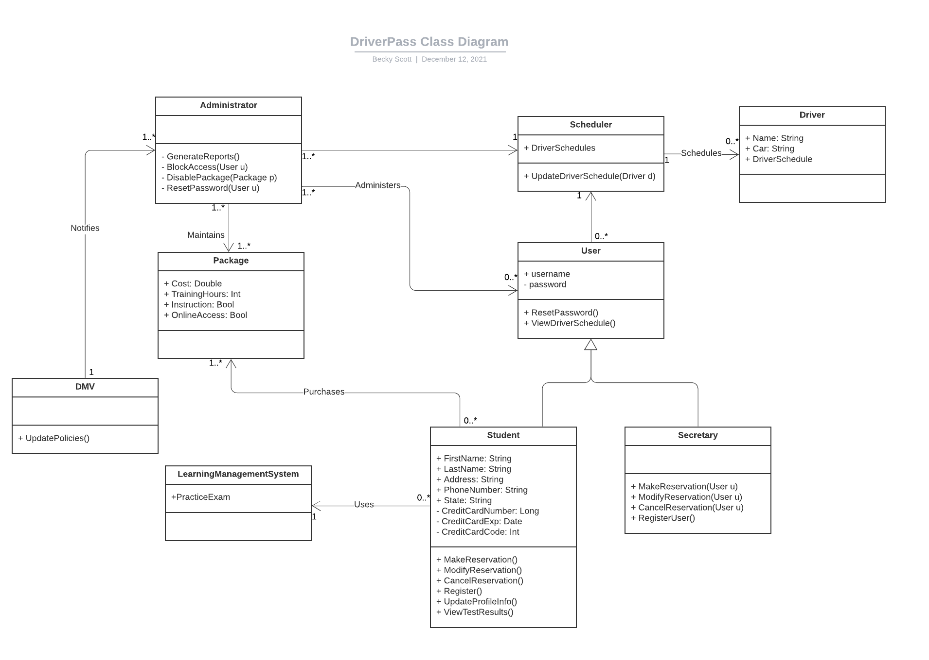

## Technical Requirements

Based on the system design discussions held between our firm and the DriverPass team, we have identified some technical requirements highlighted below:

* The system should be hosted in the cloud. The maintenance, backup, and networking should all be managed by the hosting company so DriverPass can focus on the operations. The cloud back-end would have to have some way for the administrators to access to restart the server, if necessary.
* The DriverPass system also includes the DriverPass phone system. This is a technical requirement as one mode of booking and modifying appointments is via phone.